CSC 242 Computer Architecture and Organization Spring 2021

# Homework 1: Computer Architecture and Organization (CSC 242)

## Due: Friday, January 29, 11:59 pm

**NOTE:** Please type your answers to the following questions and submit a pdf or doc on the Moodle. This assignment is to be done individually; you can discuss the questions with your classmates, but you should write your answers individually.

1. **[10 points]** Convert the following decimal numbers to binary. Show your work for:

1. 2020 = 11111100100
2. 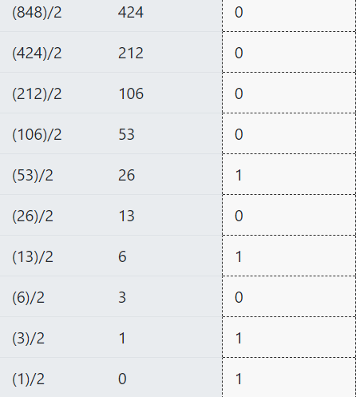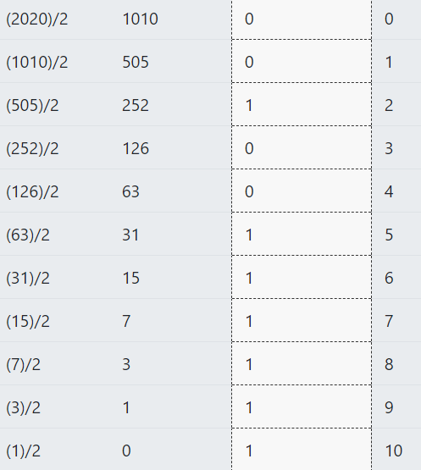848 = 1101010000

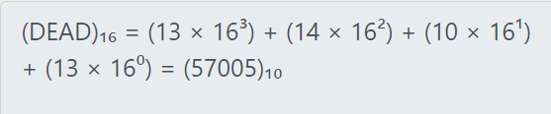2. **[10 points]** Which of the following are valid hexadecimal numbers?

1. DEAD = 57005
2. 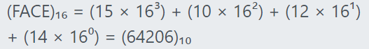AFFECT = Not a hexadecimal number
3. FACE = 64206
4. 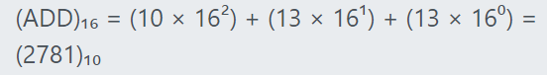ADD = 278
5. EFFECT = Not a hexadecimal number

3. **[10 points]** In class, we have seen the procedure for expressing decimal numbers in base 2 (binary), 8 (octal), and 16 (hexadecimal). In this problem, you need to extend that knowledge to convert the following decimal numbers to different number systems as mentioned below.

1. 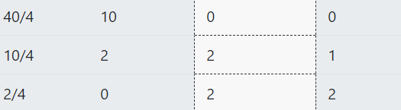Convert 40 to base 4 number system. = 220
2. 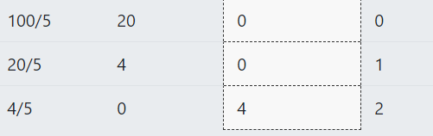Convert 100 to base 5 number system. = 400

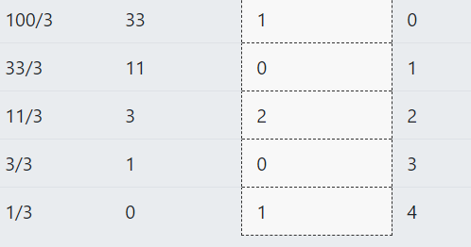(c) Convert 100 to base 3 number system. = 10201

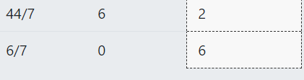(d) Convert 44 to base 7 number system. = 62

1. **[10 points]** For this question refer to the Computer Level Hierarchy on slide 14 of Introduction.pptx (available on the Moodle). As we discussed in class, level 3 (the Operating System Machine level) is usually a hybrid level. Most of the instructions at this level are also in the ISA level, i.e., level 2. Those level 3 instructions that are identical to level 2’s are executed directly by the microprogram or hardware control, not by the operating system. Is this a good execution choice? Why or why not? Yes, because the operating system inserts the necessary system library code and then in level 2 machine code is directly translated to fit the specific architecture of the CPU.
2. **[10 points]** Perform the following calculations. All numbers are in 8-bit two’s complement form. Indicate if overflow occurs.

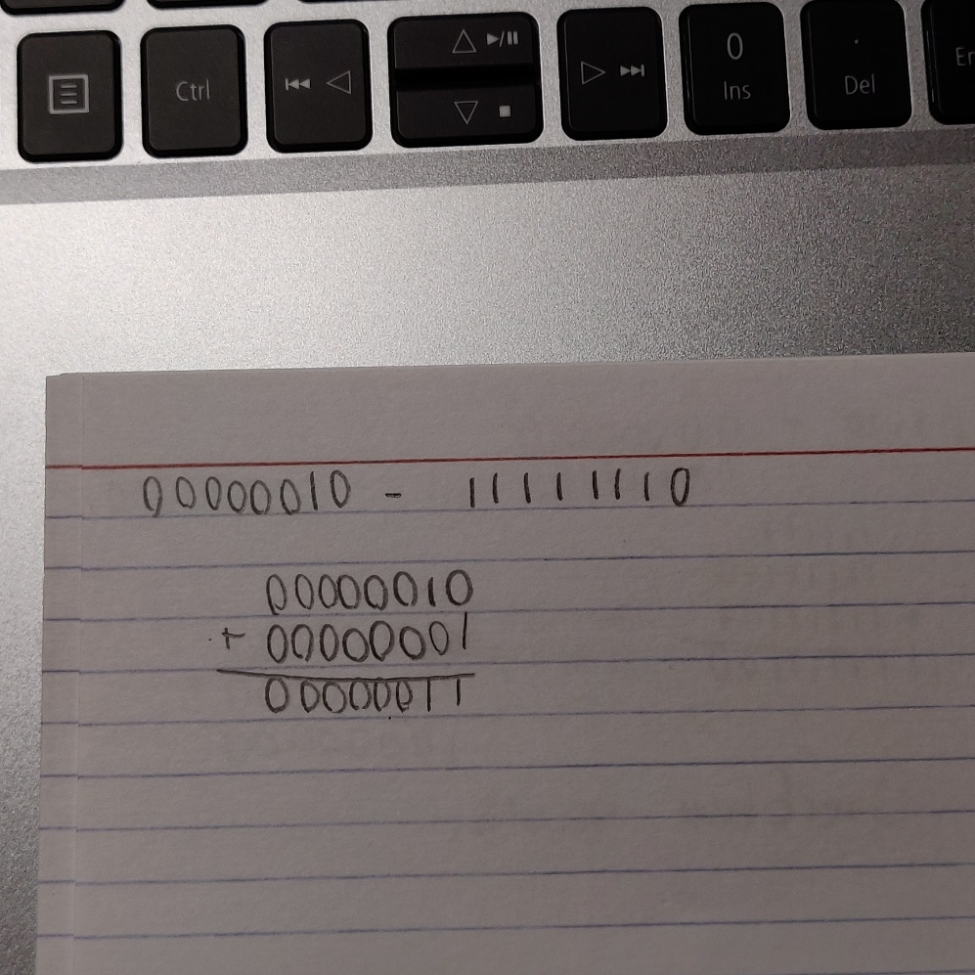(a) 00000010 - 11111110

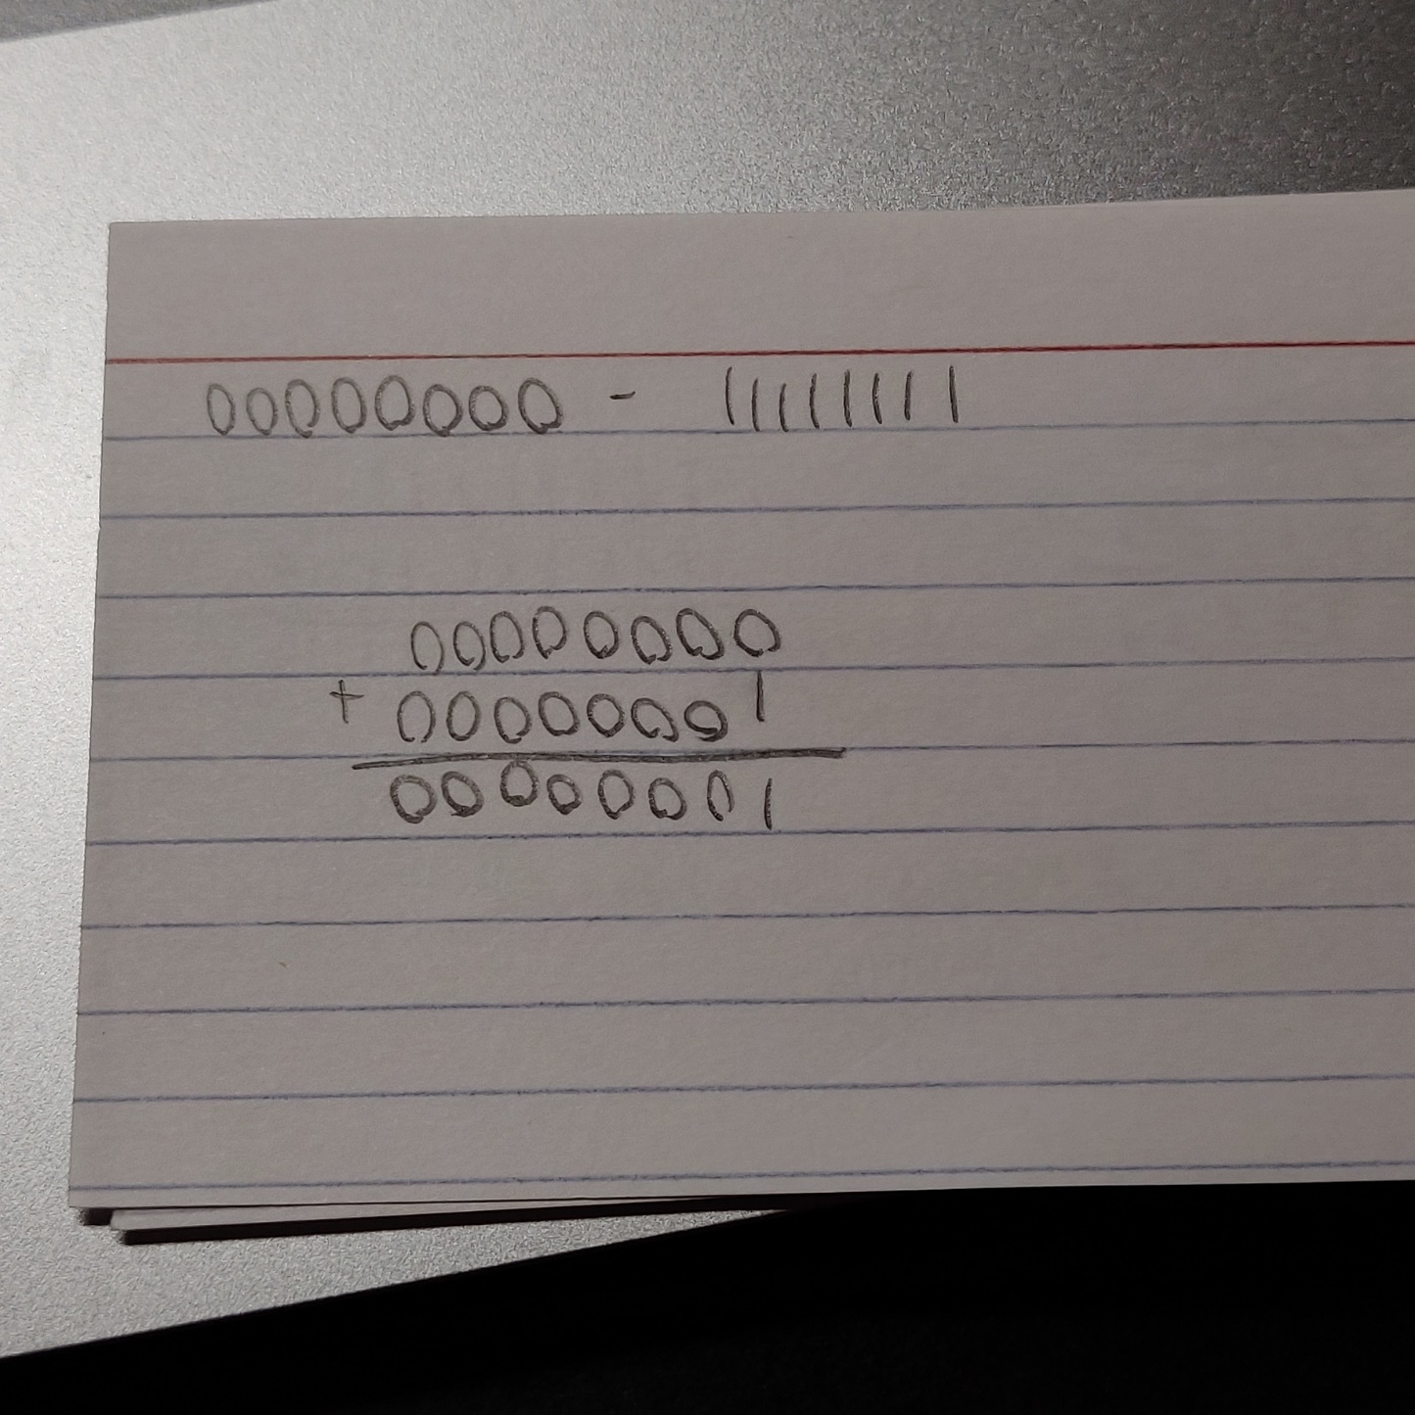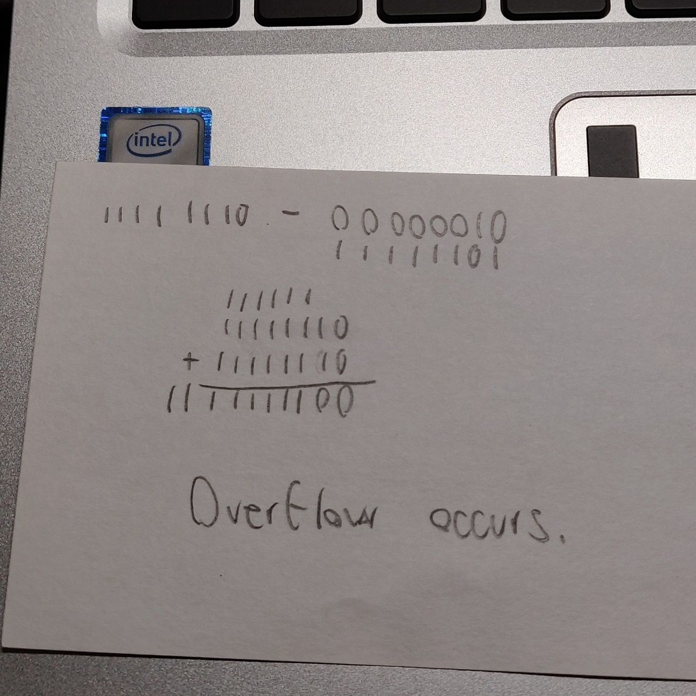(b) 11111110 - 00000010 (c) 00000000 - 11111111

1. 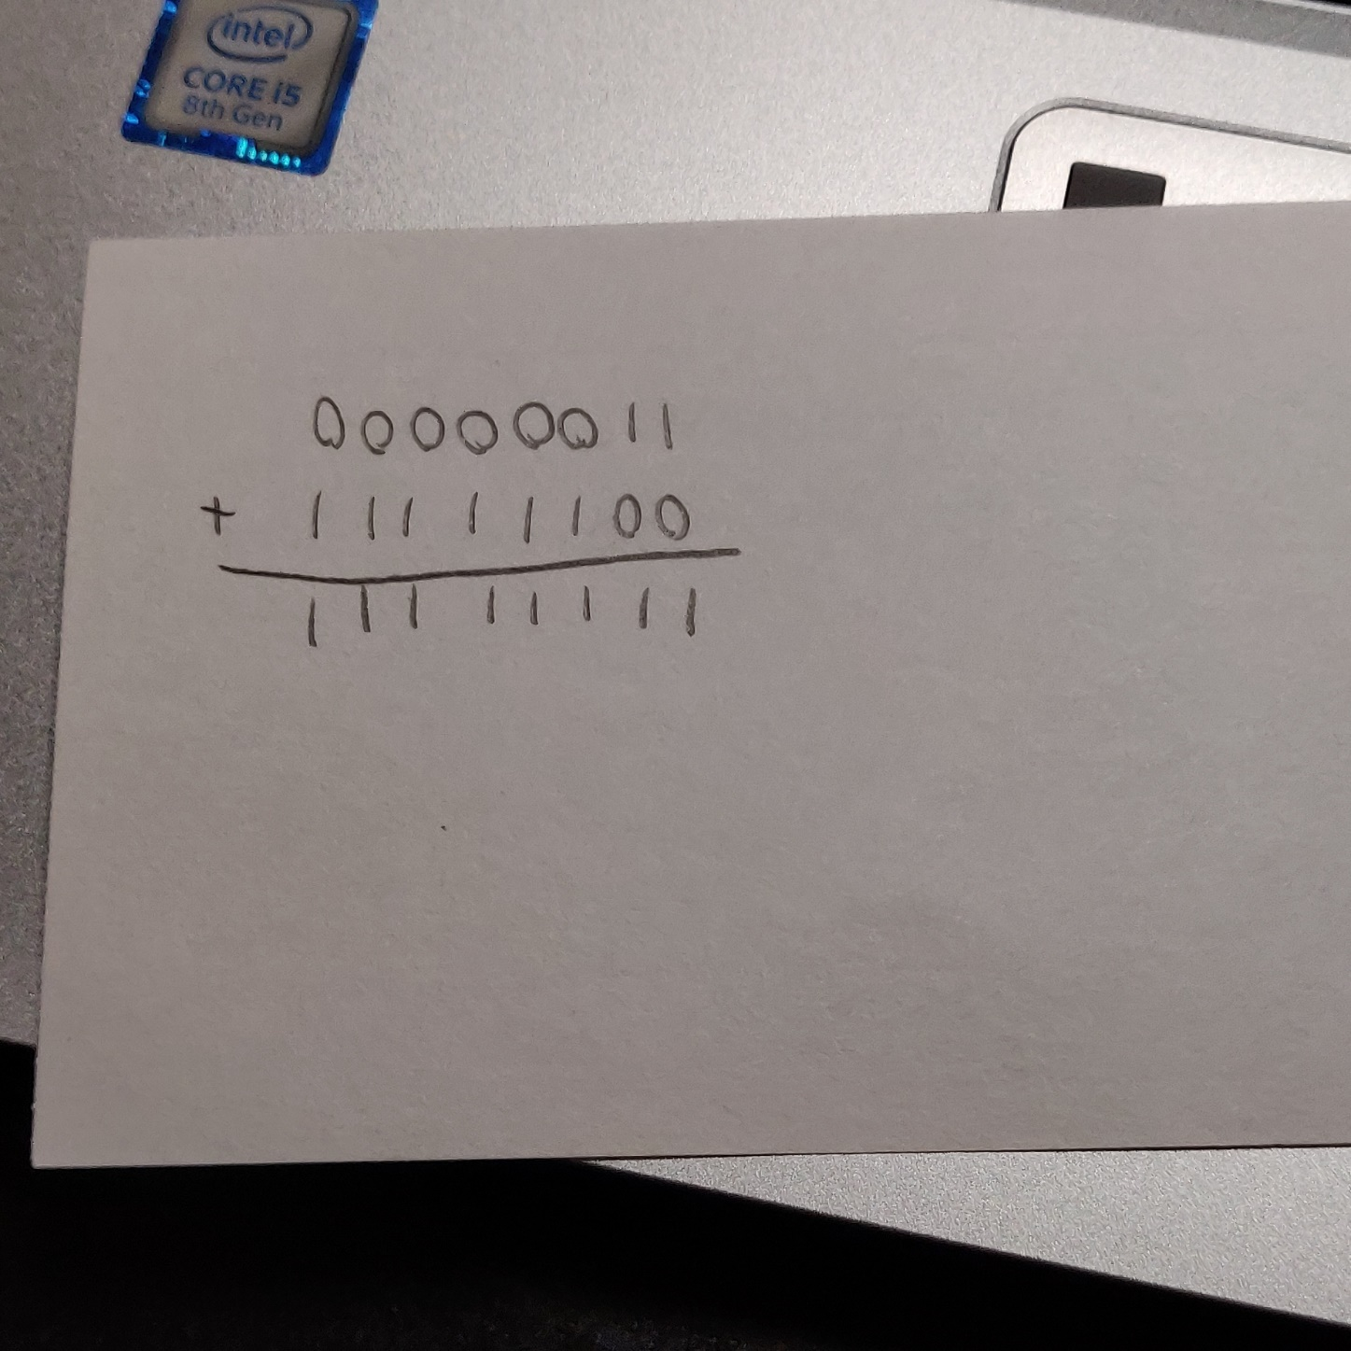00000011 + 11111100
2. 11111111 + 11111111

